**Add stock/company or document related Image here,**

*Once you add image, click on it got to “Picture format” and then from “Arrange” tab go to the “sent to back” and click sent to back option. Also make sure the wrap the image “behind text” is also checked. And manually position image.*

Incident Reporting and  
Investigation Template

**For Use in the Health Sector**

**Updated: January 22, 2025**

www.yourwebsite.com

**Add Your Company Logo/Name here**

**Table of Contents**

For Use in the Health Sector 2

How to Use This Document 2

Incident Report Form 3

Risk and Hazard Assessment 4

Immediate Response and Containment 4

Incident Investigation Form 5

Corrective and Preventative Actions (CAPA) 5

Post-Incident Review and Follow-Up 6

Supporting Documentation Checklist 6

Training Recommendations 6

# For Use in the Health Sector

## How to Use This Document

1. **Purpose**: This template enables health care organizations to document, analyze, and address workplace incidents systematically, ensuring compliance with Ontario’s Occupational Health and Safety Act (OHSA).
2. **When to Use**: Use this template to record incidents such as staff injuries, patient safety events, exposure to hazardous materials, workplace violence, or any safety-related concerns.
3. **Customization**: Personalize fields to reflect your organization’s policies, reporting hierarchy, and specific operational requirements. Consider integrating this template into digital reporting systems if applicable

# Incident Report Form

**1. Incident Overview**

* **Incident ID**: ________________________________________________
* **Date of Incident**: ________________________________________________
* **Time of Incident**: ________________________________________________
* **Location** (e.g., department, room, unit): _____________________________________
* **Type of Incident** (check all that apply):

☐ Employee Injury ☐ Patient Safety Incident

☐ Equipment Failure ☐ Biohazard or Chemical Exposure

☐ Workplace Violence or Harassment

☐ Other (specify): _________________________

**2. Individuals Involved**

* **Person Reporting the Incident**:
  + Name: _________________________
  + Position/Title: _________________________
  + Contact Information: _________________________
* **Directly Involved Individual(s)**:
  + Name: _________________________
  + Role (e.g., staff, patient, visitor): _________________________
  + Department/Unit: _________________________

**3. Incident Description**

* **Detailed Narrative**: Describe what happened in detail, including activities being performed, environmental conditions, and other relevant information.

______________________________________________________________________

______________________________________________________________________

______________________________________________________________________

* **Injuries Sustained (if any)**: Describe the nature and severity of injuries.

______________________________________________________________________

______________________________________________________________________

______________________________________________________________________

# Risk and Hazard Assessment

**4. Risk Categories (check all that apply):**

☐ Biological (e.g., infectious agents, bloodborne pathogens)

☐ Physical (e.g., slips, trips, falls)

☐ Chemical (e.g., hazardous substances, spills)

☐ Ergonomic (e.g., repetitive strain, improper lifting)

☐ Psychological (e.g., violence, harassment, burnout)

**5. Severity Assessment**

* **Actual Impact**:

☐ Minor ☐ Moderate ☐ Severe

* **Potential Impact (if unaddressed)**:

☐ Minor ☐ Moderate ☐ Severe

# Immediate Response and Containment

**6. Initial Actions**

* **Medical Assistance Provided?** ☐ Yes ☐ No
* **Type of Assistance** (e.g., first aid, emergency care): ____________________________
* **Area Secured?** ☐ Yes ☐ No
* **Describe Measures Taken**: _______________________________________________

**7. Notifications and Reporting**

* **Was the Incident Reported to a Manager or Supervisor?** ☐ Yes ☐ No
* **Date/Time of Notification**: _________________________
* **Reported to External Authorities (if required)?** ☐ Yes ☐ No
  + **Details**: _________________________________________________________

# Incident Investigation Form

**8. Investigation Team**

* **Lead Investigator**: ________________________________________________
* **Team Members**: ________________________________________________
* **Investigation Start Date**: ________________________________________________

**9. Root Cause Analysis**

* **Primary Cause(s)**:

☐ Human Error ☐ Equipment Failure ☐ Inadequate Training

☐ Policy Non-Compliance ☐ Environmental Hazards

* **Detailed Root Cause Description**:

______________________________________________________________________

______________________________________________________________________

______________________________________________________________________

# Corrective and Preventative Actions (CAPA)

**10. Action Plan**

* **Corrective Actions to Address Immediate Risks**:
* **Preventative Measures to Avoid Recurrence**:

**11. Responsibilities and Timelines**

* **Person Responsible for Implementation**: _________________________
* **Implementation Deadline**: _________________________
* **Monitoring and Follow-Up Deadline**: _________________________

# Post-Incident Review and Follow-Up

**12. Review Summary**

* **Was the Corrective Action Successful?** ☐ Yes ☐ No
  + **Details**: _________________________________________________________

**13. Long-Term Monitoring Plan**

* **Assigned Reviewer**: ____________________________________________________
* **Review Frequency**: _____________________________________________________

# Supporting Documentation Checklist

Attach the following documents as applicable:

* Photos of Incident Site
* Witness Statements
* Training Logs
* Maintenance Records (if equipment was involved)
* Incident Timeline

# Training Recommendations

**14. Staff Training Updates**

* **Training Required** (e.g., infection control, equipment use): _______________________
* **Planned Training Date**: _________________________

***Disclaimer:*** *This document is provided as a template to assist health care employers in Ontario. It is not a substitute for legal advice. Employers should consult with a legal or HR professional to ensure compliance with applicable laws and regulations. ProSupport HR Partners assumes no liability for the use of this document.*

**Please delete the last page once you are done.**

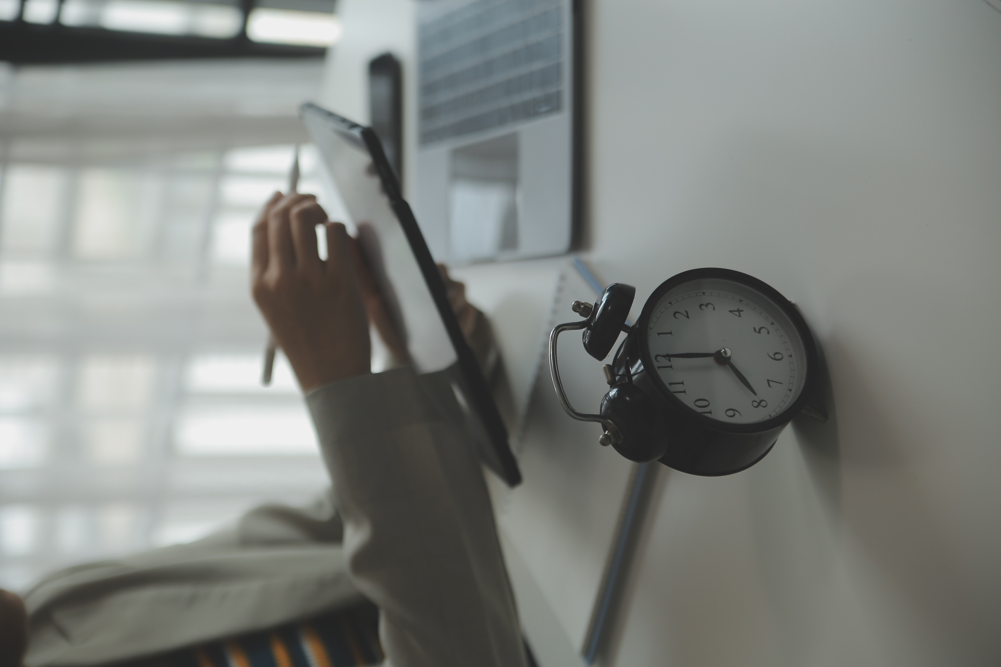



**Contact Us:**

**Email:** [contact@prosupporthr.ca](mailto:contact@prosupporthr.ca)

**Phone:** 289-628-1484

**Website:** <https://prosupporthr.ca>

**Copyright © 2025 Prosupport HR Partners**

All rights reserved. Unauthorized reproduction or distribution of this template is prohibited